**Tomcat: How to Set the JAVA_HOME Enviroment Variable**

Modify the catalina.bat file so that the servlet engine can work with Java in Tomcat.

Catalina is Tomcat’s servlet container that implements specifications for JSP and servlets. It was introduced in Tomcat version 4.x and is a core component of getting your Tomcat server up and running.

This information is stored in the file **catalina.bat**. We will have to go in manually and add in a path to our JDK install via the JAVA_HOME environmental variable.

1. Navigate to the directory where Tomcat is installed, and go into the **\bin** folder (**c:\tomcat\bin**). Right-click the file **catalina.bat**, and then select **Edit**. (I used Notepad++, but regular Notepad is fine.)

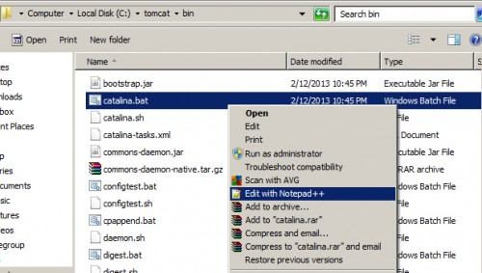

1. Scroll down in the code until you pass the end of the beginning “rem” comments, and insert the following code pointing to your JDK’s root directory:

|  |
| --- |
| set JAVA_HOME=C:\Program Files (x86)\Java\jdk1.7.0_06 |

Be sure you are pointing to YOUR computer’s location of the JDK, not the exact one listed above.

1. Save your changes, and restart Tomcat.

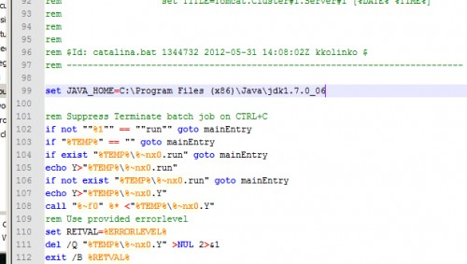

1. Catalina.bat is part of Tomcat, the open source web server and servlet container for rendering and displaying JSP/Servlet powered web pages.